**AIM: -** To design a system for cars such that whenever someone walks long front side, Red LED starts blinking once every 10 ms and if someone walks along its back, Green LED starts blinking once every 20 ms

**APPARATUS: -** Arduino Board , LED,PIR(Passive infra red) sensor, Resistance- 220ohm, connecting wires.

**CIRCUIT DIAGRAM: -**

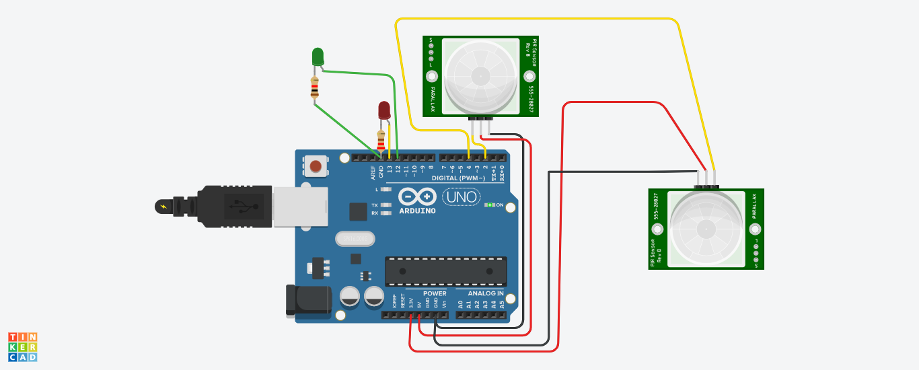

**THEORY: -**

A passive infrared **sensor** (**PIR sensor**) is an electronic **sensor** that measures infrared (IR) light radiating from objects in its field of view. They are most often used in **PIR**-based **motion** detectors.

**PIR sensors** allow you to sense motion, almost always used to detect whether a human has moved in or out of the sensors range.

**OBSERVATION: -**

Blinking of Red LED when infront and blinking of green light when back side

**PRECAUTIONS: -**

1. Insert connecting wires properly/ tightly .
2. Insert the wire in correct pin.
3. Declare pinMode correctly.
4. Write the arduino code properly.